VISVESVARAYA TECHNOLOGICAL UNIVERSITY
“JnanaSangama”, Belgaum -590014, Karnataka.


LABREPORT
on

BIGDATAANALYTICS(20CS6PEBDA)

Submittedby

MOHD IRFAN(1BM20CS409)

inpartialfulfillmentfortheawardofthedegreeof
BACHELOROFENGINEERING
in
COMPUTER SCIENCEANDENGINEERING


B.M.S.COLLEGEOFENGINEERING
(AutonomousInstitutionunderVTU)
BENGALURU-560019
May-2022toJuly-2022

B.M.S.CollegeofEngineering,
BullTempleRoad,Bangalore560019
(AffiliatedToVisvesvarayaTechnologicalUniversity,Belgaum)
DepartmentofComputerScienceandEngineering


CERTIFICATE

This is to certify that the Lab work entitled “BIGDATAANALYTICS” carried out by MOHD IRFAN(1BM20CS409),who is bonafide student of B.M.S. College of Engineering.It is in partial fulfillment for the award ofBachelor of Engineering in Computer Science and Engineering of the Visvesvaraya Technological University, Belgaum during the year 2022. The Lab report has been approved as it satisfies the academic requirements in respec tof a Big Data Analytics-(20CS6PEBDA)work prescribed for the said degree.

AntaraRoyChoudhury
NameoftheLab-Incharge Dr.JyothiSNayak
Designation ProfessorandHead
DepartmentofCSE DepartmentofCSE
BMSCE,Bengaluru BMSCE,Bengaluru

`

IndexSheet

Sl.  No. | ExperimentTitle | PageNo.
1 | Employee Database
2 | Library Database
3 | Mongo Db

CourseOutcome

CO1 | ApplytheconceptofNoSQL,HadooporSparkforagiventask
CO2 | AnalyzetheBigDataandobtaininsightusingdataanalyticsmechanisms.
CO3 | DesignandimplementBigdataapplicationsbyapplyingNoSQL,HadooporSpark

Program1.PerformthefollowingDBoperationsusingCassandra.
- CreateakeyspacebynameEmployee
- CreateacolumnfamilybynameEmployee-InfowithattributesEmp_IdPrimaryKey,Emp_Name,Designation,Date_of_Joining,Salary,Dept_Name
- Insertthevaluesintothetableinbatch
- UpdateEmployeenameandDepartmentofEmp-Id121
- SortthedetailsofEmployeerecordsbasedonsalary
- AltertheschemaofthetableEmployee_InfotoaddacolumnProjectswhichstoresasetofProjectsdonebythecorrespondingEmployee.
- Updatethealteredtabletoaddprojectnames.
8CreateaTTLof15secondstodisplaythevaluesofEmployees.
cqlsh> create keyspace "Employee" with replication={
... 'class':'SimpleStrategy','replication_factor':1}; cqlsh> describekeyspaces;

"Employee" system_auth system_schema system_views system system_distributed system_traces system_virtual_schema
cqlsh>USE "Employ e e";
cqlsh:Employee> create table employee_info( Emp_Id int PRIMARY KEY, Emp_Name text,Designation text, Date_Of_joining timestamp, Salary int, Dept_Name text);
cqlsh:Employee> describe emp loye e_info;

CREATETABLE"Employee".employee_info(em p _ I d I n t PRIMARY KEY,date_of_joining timestamp, dept_nametext,
designation text,emp_name text,sallary int
) WITH additional_write_policy= '99p' AND b l o o m _ f il t e r_f p_ c h a n c e = 0 . 0 1
AND caching= {'keys': 'ALL', 'rows_per_partition': 'NONE'} AND cdc =fa l s e
AND comment = ''
AND compaction={'class':'org.apache.cassandra.db.compaction.SizeTieredCompactionStrategy',' max_threshold': '32', 'min_threshold': '4'}
AND compression = {'chunk_length_in_kb': '16', 'class':'org. Ap ac he. Cassandra .io. Compress .LZ4 Compressor' }
AND crc_check_chance = 1.0AND default_time_to_live = 0AND extensions = {}
AND gc_grace_seconds = 864000AND max_index_interval = 2048
AND memtable_flush_period_in_ms = 0AND min_index_in t er v al = 128
AND read_repair = 'BLOCKING'AND speculative_retry = '99 p';

cqlsh:Employee>BEGINBATCH.. INSERT INTO
employee_info(Emp_Id,Emp_Name,Designation,Date_Of_joining,Salary,Dept_Name)VALUES(11,'joseph','manager','2020-03-13',19000,'IT')
...INSERTINTO
employee_info(Emp_Id,Emp_Name,Designation,Date_Of_joining,Salary,Dept_Name)VALUES(12,'bob','Softwareengineer','2021-06-23',90000,'IT')
...INSERTINTO
employee_info(Emp_Id,Emp_Name,Designation,Date_Of_joining,Salary,Dept_Name)VALUES(13,'smith','Manager','2019-04-05',90000,'Sales')
...APPLYBATCH;
cqlsh:Employee> SELECT* FROM employee_info;
emp_id | date_of_joining| dept_name | designation|emp_n a m e | sa l a ry
--------+---------------------------------+-----------+--------------------+----------+--------
11 | 020-03-13 00:00:00.000000+0000 |IT |Manager |John | 19000
12 | 2021-06-23 00:00:00.000000+0000 |IT|Softwareengineer|bob | 90000
13 | 2019-04-05 00:00:00.000000+0000 |IT| manager| smith| 90000
(3 rows)
cqlsh:Employee>UPDATE employee_info SET Emp_Name='Rosy',Dept_Name='Software' WHERE Emp_Id = 121;
cqlsh : Employee> SELECT* FROM employee_info;
emp_id | date_of_joining| dept_name | designation|emp_name | s a l a r y
--------+---------------------------------+-----------+--------------------+----------+--------
11 | 020-03-13 00:00:00.000000+0000 |IT |Manager |John | 19000
12 | 2021-06-23 00:00:00.000000+0000 |IT|Softwareengineer|bob | 90000
13 | 2019-04-05 00:00:00.000000+0000 |IT| manager| smith| 90000

(3 rows)

cqlsh:Employee>ALTERTABLEemployee_info
... ADD projects set<text>;cqlsh:Employee>SELECT* FROM employee_info;

emp_id | date_of_joining| dept_name | designation|emp_n a m e | projects | s a l a ry--- +---------------------------------+-----------+--------------------+----------+----------+--------
11 | 020-03-13 00:00:00.000000+0000 |IT |Manager |John | null| 19000
12 | 2021-06-23 00:00:00.000000+0000 |IT|Softwareengineer|bob |null| 90000
13 | 2019-04-05 00:00:00.000000+0000 |IT| manager| smith|mull| 90000
(3 rows)

cqlsh:Employee>UPDATE employee_infoSETprojects={'sales improvement proj','admanagement sys'}WHERE Emp_ID=13;
cqlsh:Employee>UPDATE employee_info SET projects={'companywebsite','Employee managementapp'}WHERE Emp_ID=11;
cqlsh:Employee>UPDATE employee_info SET projects={'companywebsitetesting'}WHERE Emp_ID=12;
cqlsh:Employee> SELECT* FROM employee_info;
emp_id | date_of_joining| dept_name | designation|emp_name | projects| salary-------+---------------------------------+-----------+--------------------+-----------------------------------------------------------+--------
11 | 020-03-13 00:00:00.000000+0000 |IT |Manager |John | companywebsite |19000
12 | 2021-06-23 00:00:00.000000+0000 |IT|Softwareengineer|bob | companywebsitetesting |90000
13 | 2019-04-05 00:00:00.000000+0000 |IT| manager| smith| sales improvement proj |90000
(3 rows)

cqlsh:Employee>BEGINBATCH
...INSERTINTO
employee_info(Emp_Id,Emp_Name,Designation,Date_Of_joining,Salary,Dept_Name,projects
)VALUES(124,'Joe','Intern','2021-03-20',25000,'IT',{'LMS'})USINGTTL15
...APPLYBATCH;

11 | 020-03-13 00:00:00.000000+0000 |IT |Manager |John | 19000
12 | 2021-06-23 00:00:00.000000+0000 |IT|Softwareengineer|bob | 90000
13 | 2019-04-05 00:00:00.000000+0000 |IT| manager| smith| 90000
124 2021-03-20 00:00:00.000000+0000|IT|{lms}|Using TTL15
(4 rows)
cqlsh:Employee> SELECT* FROM employee_info;
emp_id | date_of_joining| dept_name | designation|emp_name | projects| salary--------+---------------------------------+-----------+--------------------+----------------------------------------------------------+--------
11 | 020-03-13 00:00:00.000000+0000 |IT |Manager |John | 19000
12 | 2021-06-23 00:00:00.000000+0000 |IT|Softwareengineer|bob | 90000
13 | 2019-04-05 00:00:00.000000+0000 |IT| manager| smith| 90000
124 |2021-03-20 00:00:00.000000+0000|IT|{lms}|Using TTL15

Program 2:
1CreateakeyspacebynameLibrary
  - CreateacolumnfamilybynameLibrary-InfowithattributesStud_IdPrimaryKey,Counter_valueoftypeCounter,
Stud_Name,Book-Name,Book-Id,Date_of_issue
  - Insertthevaluesintothetableinbatch
  - Displaythedetailsofthetablecreatedandincreasethevalueofthecounter
  - Writeaquerytoshowthatastudentwithid112hastakenabook“BDA”2times.
  - Exportthecreatedcolumntoacsvfile
  - ImportagivencsvdatasetfromlocalfilesystemintoCassandracolumnfamily

cqlsh>CREATEKEYSPACE"library"WITHREPLICATION={'class':'SimpleStrategy','replication_factor':1};

cqlsh> use "library";

cqlsh:library>CREATETABLELIBRARY_INFO(STUD_IDINT,COUNTER_VALUECOUNTER,STUD_NAMETEXT,BOOK_NAMETEXT,BOOK_IDINT,DATE_OF_ISSUETIMESTAMP,PRIMARYKEY(STUD_ID,STUD_NAME,BOOK_NAME,BOOK_ID,DATE_OF_ISSUE));

cqlsh:library>describetablelibrary_info;CREATETABLElibrary.library_info(
stud_id int,stud_name text,book_name text,book_ I d I n t,
date_of_issue timestamp, counter_valueco un t e r ,
PRIMARYKEY(stud_id,stud_name,book_name,book_id,date_of_issue)
)WITHCLUSTERINGORDERBY(stud_nameASC,book_nameASC,book_idASC,d a t e_ o f _i s su eA S C)
AND bloom_filter_fp_chance = 0.01
AND caching={'keys':'ALL','rows_per_partition':'NONE'}AND co m m e nt = ''
ANDcompaction={'class':'org.apache.cassandra.db.compaction.SizeTieredCompactionStrategy',' m ax _ th r es h o l d ' : ' 3 2 ' , ' m in _ t h r e s h ol d' : ' 4' }
AND compression = {'chunk_length_in_kb': '64', 'class': 'o r g . ap a c he . Ca s s an d r a. io . C o m pr e ss . LZ 4C o mp r e ss o r'}
AND crc_check_chance = 1.0
AND dclocal_read_repair_chance = 0.1AND d ef au l t_ t im e _t o_ l iv e = 0
AND gc_grace_seconds = 864000AND m a x _i nd e x _ in t er v al = 2 0 4 8
AND memtable_flush_period_in_ms = 0
AND min_index_interval = 128 AN D rea d _ re p ai r _c h a n c e = 0.0
AND speculative_retry = '99PERCENTILE';

cqlsh:library>UPDATELibrary_InfoSETCounter_Value=Counter_Value+1whereS tu d _ Id = 1 a nd St u d_ N a me =' A n k I t' a n d B oo k _na m e= ' BD A' and Bo ok_ id= 11 1 a nd D a te_Of_Issue='2021-03-15';
cqlsh:library> UPDATE Library_Info SET Counter_value=Counter_value+1 whereStud_Id=2andStud_Name='Jennifer'andBook_name='OOMD'andBook_id=112andDate_Of_Issue='2021-02-14';
cqlsh:library>UPDATELibrary_InfoSETCounter_value=Counter_value+1whereStud_Id=112andStud_Name='Aswin'andBook_name='BDA'andBook_id=1123andDate_Of_Issue='2021-01-18';
cqlsh:library>UPDATELibrary_InfoSETCounter_value=Counter_value+1whereStud_Id=112andStud_Name='Aswin'andBook_name='BDA'andBook_id=1123andDate_Of_Issue='2021-01-18';

select * from library_info;
cqlsh:library>UPDATELibrary_InfoSETCounter_Value=Counter_Value+1whereStud_Id=1andStud_Name='Ankit'andBook_name='BDA' andBook_id=111and
Date_Of_Issue='2021-03-15';
select*fromlibrary_infowherestud_id=112
;c q ls h :l I b r a ry > COPY
Library_Info(Stud_Id,Stud_Name,Book_Name,Book_Id,Date_Of_Issue,Counter_value)TO
'/home/bmsce/Desktop/library_info.csv';Using11 child processes

Startingcopyoflibrary.library_infowithcolumns[stud_id,stud_name,book_name,book_id,d a te _ of_ I ss ue , c o unt e r _v a l ue ].
Processed: 4 rows; Rate: 32rows/s;Avg.rate: 32 rows/s4 ro w s e x po r t ed t o 1 f I l es I n 0 . 1 35 s eco n ds .

cqlsh:library>CREATETABLELibrary_Info_Import(Stud_Idint,Counter_valuecounter,S tud _ N am e t ex t, B o o k_ N a m e t e xt , B o ok _ I d I nt , Da t e_ O f _ Is s u e t I m e st a mp , PRIMARYKEY(Stud_Id,Stud_Name,Book_Name,Book_Id,Date_Of_Issue)); cqlsh:library> copylibrary_Info_Import from '/home/bmsce/Desktop/library_info.csv';
Using11childprocesses

Startingcopyoflibrary.library_info_importwithcolumns[stud_id,stud_name,book_name,book_id,da te_o f_i s su e, c o u nt e r _ v al u e ].
Processed: 4 rows; Rate: 7rows/s;Avg.rate: 10 rows/s 4 rows im p o rt e d f r o m 1 f il e s I n 0.
383 seconds (0 skipped).

MONGO DB

>use mySTUD;switchedtodbmySTUD
- db.getCollectionNames() [ ]
- db.createCollection("Student");
{ "ok" : 1 }
- db.getCollectionNames() [ "Student" ]
- db.Student.insert({_id: 1, Name:"John", USN: "1B22CS001",Semester: 6,Dept_name:"CSE",CGPA: 9.6,Hobbies : ["Reading","Gardening"]})
WriteResult({"nInserted":1})
- db.Student.insert({_id: 4, Name:"Arthur", USN: "1B22CS041",Semester: 6,Dept_name: "CSE",CGPA:8.6, Hobbies : ["NovelReading"]})
WriteResult({"nInserted":1})
- db.Student.insert({_id: 3, Name:"Horris", USN: "1B22EE021",Semester: 5,Dept_name: "EEE",CGPA:9.3, Hobbies : ["eSports"]})
WriteResult({"nInserted":1})
- db.Student.insert({_id: 7, Name:"Hritik", USN: "1B22CS014",Semester: 5,Dept_name: "CSE",CGPA:8.7, Hobbies : ["Reading"]})
WriteResult({"nInserted":1})
- db.Student.find().pretty()
{
"_id" : 1, "Name" :"John",
"USN" : "1B22CS001",
"Semester" : 6,"Dept_name":"CSE",
"CGPA":9.6,
"Hobbies" : [
"Reading","Gardening"
]
}
{
"_id" : 4,
"Name" : "Arthur",
"USN" : "1B22CS041",
"Semester" : 6,"Dept_name":"CSE",
"CGPA":8.6,
"Hobbies" : [
"Novel Reading"
]
}
{
"_id" : 3,
"Name" : "Horris",
"USN" : "1B22EE021",
"Semester" : 5,"Dept_name":"EEE",
"CGPA":9.3,
"Hobbies" : [
"eSports"
]
}
{
"_id" : 7,
"Name" : "Hritik",
"USN" : "1B22CS014",
"Semester" : 5,"Dept_name":"CSE",
"CGPA":8.7,
"Hobbies" : [
"Reading"
]
}

- db.Student.update({_id: 3, Name:"Horris", USN: "1B22EE021",Semester: 5,Dept_name:"EEE",CGPA: 9.3},{$set:{Hobbies:"Skating"}},{upset:true});
WriteResult({"nMatched":1,"nUpserted":0,"nModified": 1})
- db.Student.find().pretty()
{
"_id" : 1, "Name" :"John",
"USN" : "1B22CS001",
"Semester" : 6,"Dept_name":"CSE",
"CGPA":9.6,
"Hobbies" : [
"Reading","Gardening"
]
}
{
"_id" : 4,
"Name" : "Arthur",
"USN" : "1B22CS041",
"Semester" : 6,"Dept_name":"CSE",
"CGPA":8.6,
"Hobbies" : [
"Novel Reading"
]
}
{
"_id" : 3,
"Name" : "Horris",
"USN" : "1B22EE021",
"Semester" : 5,"Dept_name":"EEE",
"CGPA":9.3,
"Hobbies" : "Skating"
}
{
"_id" : 7,
"Name" : "Hritik",
"USN" : "1B22CS014",
"Semester" : 5,"Dept_name":"CSE",
"CGPA":8.7,
"Hobbies" : [
"Reading"
]
}
- db.Student.find({},{StudName:1,Semester:1,_id:0});
{ "Semester" : 6 }
{ "Semester" : 6 }
{ "Semester" : 5 }
{ "Semester" : 5 }
- db.Student.find({},{Name:1,Semester:1,_id:0});
{ "Name" : "John", "Semester" : 6 }
{ "Name" : "Arthur", "Semester" : 6 }
{ "Name" : "Horris", "Semester" : 5 }
{ "Name" : "Hritik", "Semester" : 5 }

- db.Student.find({Semester:{$eq:5}}).pretty();
{
"_id" : 3,
"Name" : "Horris",
"USN" : "1B22EE021",
"Semester" : 5,"Dept_name":"EEE",
"CGPA":9.3,
"Hobbies" : "Skating"
}
{
"_id" : 7,
"Name" : "Hritik",
"USN" : "1B22CS014",
"Semester" : 5,"Dept_name":"CSE",
"CGPA":8.7,
"Hobbies" : [
"Reading"
]
}
- db.Student.count()
; 4
- db.Student.find().sort({Name:-1}).pretty();
{
"_id" : 1, "Name" :"John",
"USN" : "1B22CS001",
"Semester" : 6,"Dept_name":"CSE",
"CGPA":9.6,
"Hobbies" : [
"Reading","Gardening"
]
}
{
"_id" : 7,
"Name" : "Hritik",
"USN" : "1B22CS014",
"Semester" : 5,"Dept_name":"CSE",
"CGPA":8.7,
"Hobbies" : [
"Reading"
]
}
{
"_id" : 3,
"Name" : "Horris",
"USN" : "1B22EE021",
"Semester" : 5,
"Dept_name" : "EEE",
"CGPA":9.3,
"Hobbies" : "Skating"
}
{
"_id" : 4,
"Name" : "Arthur",
"USN" : "1B22CS041",
"Semester" : 6,"Dept_name":"CSE",
"CGPA":8.6,
"Hobbies" : [
"Novel Reading"
]
}

(base) bmsce@bmsce-Precision-T1700:~$ mongoexport --host localhost --db mySTUD -- collectionStudent--type=csv--fields="_id,Name,USN,Semester,Dept_name,CGPA,Hobbies"--out
/home/bmsce/Desktop/output.csv
2022-05-06T12:13:37.350+0530 connected to: localhost2022-05-06T12:13:37.351+0530 exported 4 records (base)bmsce@bmsce-Precision-T1700:~$ mongo
MongoDB shell version v3.6.8
connecting to: mongodb://127.0.0.1:27017
Implicit session: session { "id" : UUID("aabd8226-3ced-43d4-97fb-b0d55827849c") } MongoDB serverversion: 3.6.8
Server has startup warnings:
2022-05-06T11:28:08.073+0530ISTORAGE[initandlisten]
2022-05-06T11:28:08.073+0530ISTORAGE[initandlisten]**WARNING:UsingtheXFSfilesystemisstrongly recommended withtheWiredTiger storage engine
2022-05-06T11:28:08.073+0530ISTORAGE[initandlisten]** Seehttp://dochub.mongodb.org/core/prodnotes-filesystem
2022-05-06T11:28:13.281+0530ICONTROL[initandlisten]
2022-05-06T11:28:13.281+0530 ICONTROL[initandlisten]**WARNING:Access control is notenabled for the database.
2022-05-06T11:28:13.281+0530ICONTROL[initandlisten]** Read and writeaccess to data and configuration is unrestricted.
2022-05-06T11:28:13.281+0530ICONTROL[initandlisten]
- use mySTUD;switchedtodbmySTUD
- db.Student.update({_id:4},{$set:{Location:”Network”}})
2022-05-06T12:16:35.289+0530EQUERY [thread1] SyntaxError: illegal character@(shell):1:42
- db.Student.update({_id:4},{$set:{Location:"Network"}})WriteResult({"nMatched" : 1, "nUpserted" : 0, "nModified" : 1 })
- db.Student.find().pretty()
{
"_id" : 1, "Name" :"John",
"USN" : "1B22CS001",
"Semester" : 6,"Dept_name":"CSE",
"CGPA":9.6,
"Hobbies" : [
"Reading","Gardening"
]
}
{
"_id" : 4,
"Name" : "Arthur",
"USN" : "1B22CS041",
"Semester" : 6,"Dept_name":"CSE",
"CGPA":8.6,
"Hobbies" : [
"Novel Reading"
],
"Location" : "Network"
}
{
"_id" : 3,
"Name" : "Horris",
"USN" : "1B22EE021",
"Semester" : 5,"Dept_name":"EEE",
"CGPA":9.3,
"Hobbies" : "Skating"
}
{
"_id" : 7,
"Name" : "Hritik",
"USN" : "1B22CS014",
"Semester" : 5,"Dept_name":"CSE",
"CGPA":8.7,
"Hobbies" : [
"Reading"
]
}
- db.Student.find().sort({Name:1}).pretty();
{
"_id" : 4,
"Name" : "Arthur",
"USN" : "1B22CS041",
"Semester" : 6,"Dept_name":"CSE",
"CGPA":8.6,
"Hobbies" : [
"Novel Reading"
],
"Location" : "Network"
}
{
"_id" : 3,
"Name" : "Horris",
"USN" : "1B22EE021",
"Semester" : 5,"Dept_name":"EEE",
"CGPA":9.3,
"Hobbies" : "Skating"
}
{
"_id" : 7,
"Name" : "Hritik",
"USN" : "1B22CS014",
"Semester" : 5,
"Dept_name" : "CSE",
"CGPA":8.7,
"Hobbies" : [
"Reading"
]
}
{
"_id" : 1, "Name" :"John",
"USN" : "1B22CS001",
"Semester" : 6,"Dept_name":"CSE",
"CGPA":9.6,
"Hobbies" : [
"Reading","Gardening"
]
}

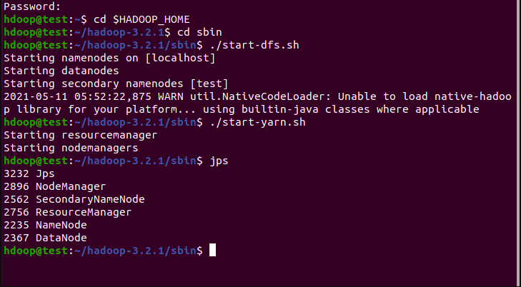
4. Screenshot of Hadoop installed

5 Execution of HDFS Commands for interaction with Hadoop
Environment. (Minimum 10 commands to be executed)Hadoop Basic Commands
1. mkdir
Hadoop HDFS mkdir Command Usage
mkdir
Hadoop HDFS mkdir Command Example
hdfs dfs -mkdir /abc
Hadoop HDFS mkdir Command Description
This HDFS command takes path URI’s as an argument and creates directories.

2. ls
Hadoop HDFS ls Command Usage
ls
Hadoop HDFS ls Command Example
hadoop fs -ls /
Hadoop HDFS ls Commnad Description
This Hadoop HDFS ls command displays a list of the contents of a directory specified by path provided by the user, showing the names, permissions, owner, size and modification date for each entry.

3. put
Hadoop HDFS put Command Usage
put
Hadoop HDFS put Command Example
hdfs dfs -put /home/hduser/Desktop/Welcome.txt /abc/WC.txt
Hadoop
HDFS put Command Description
This hadoop basic command copies the file or directory from the local file system to the destination within the DFS.
Display the contents of the file WC.txt
hdfs dfs -cat /abc/WC.txt

4. copyFromLocal
Hadoop HDFS copyFromLocal Command Usage
copyFromLocal
Hadoop HDFS copyFromLocal Command Example
hdfs dfs -put /home/hduser/Desktop/Welcome.txt /abc/WC.txt
Hadoop HDFS copyFromLocal Command Description
This hadoop shell command is similar to put command, but the source is restricted to a local file reference.
Display the contents of the file WC2.txt
hdfs dfs -cat /abc/WC2.txt

5. get
Hadoop HDFS get Command Usage
get [-crc]
i.Hadoop HDFS get Command Example
hdfs dfs -get /abc/WC.txt /home/hduser/Downloads/WWC.txt

This HDFS fs command copies the file or directory in HDFS identified by the source to the local file system path identified by local destination.

ii.Hadoop HDFS get Command Example
hdfs dfs -getmerge /abc/WC.txt /abc/WC2.txt /home/hduser/Desktop/Merge.txt

This HDFS basic command retrieves all files that match to the source path entered by the user in HDFS, and creates a copy of them to one single, merged file in the local file system identified by local destination.

iii. Hadoop HDFS get Command Example
hadoop fs -getfacl /abc/

This Apache Hadoop command shows the Access Control Lists (ACLs) of files and directories.

6. copyToLocal
Hadoop HDFS copyToLocal Command Usage
copyToLocal
Hadoop HDFS copyToLocal Command Example
hdfs dfs -copyToLocal /abc/WC.txt /home/hduser/Desktop

Similar to get command, only the difference is that in this the destination is restricted to a local file reference.

7. cat
Hadoop HDFS cat Command Usage
cat
Hadoop HDFS cat Command Example
hdfs dfs -cat /abc/WC.txt

This Hadoop fs shell command displays the contents of the filename on console or stdout.

8. mv
Hadoop HDFS mv Command Usage
mv
Hadoop HDFS mv Command Example
hadoop fs -mv /abc /FFF
hadoop fs -ls /FFF

This basic HDFS command moves the file or directory indicated by the source to destination, within HDFS.

9. cp
Hadoop HDFS cp Command Usage
cp
Hadoop HDFS cp Command Example
hadoop fs -cp /CSE/ /LLL
hadoop fs -ls /LLL
The cp command copies a file from one directory to another directory within the HDFS.

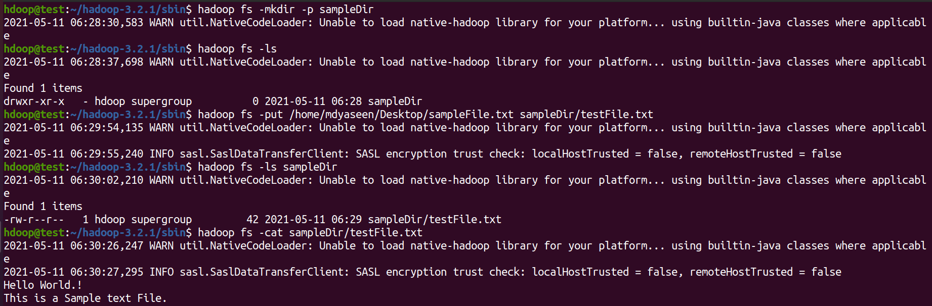

Create a Map Reduce program to
a) find average temperature for each year from NCDC dataAverageDriver
package temp;
import org.apache.hadoop.fs.Path;
import org.apache.hadoop.io.IntWritable;
import org.apache.hadoop.io.Text;
import org.apache.hadoop.mapreduce.Job;
import org.apache.hadoop.mapreduce.lib.input.FileInputFormat;
import org.apache.hadoop.mapreduce.lib.output.FileOutputFormat;
public class AverageDriver {
public static void main(String[] args) throws Exception {
if (args.length != 2) {
System.err.println(&quot;Please Enter the input and output
parameters&quot;);
System.exit(-1);
}
Job job = new Job();
job.setJarByClass(AverageDriver.class);
job.setJobName(&quot;Max temperature&quot;);
FileInputFormat.addInputPath(job, new Path(args[0]));
FileOutputFormat.setOutputPath(job, new Path(args[1]));
job.setMapperClass(AverageMapper.class);
job.setReducerClass(AverageReducer.class);
job.setOutputKeyClass(Text.class);

job.setOutputValueClass(IntWritable.class);
System.exit(job.waitForCompletion(true) ? 0 : 1);
}
}
AverageMapper
package temp;
import java.io.IOException;
import org.apache.hadoop.io.IntWritable;
import org.apache.hadoop.io.LongWritable;
import org.apache.hadoop.io.Text;
import org.apache.hadoop.mapreduce.Mapper;
public class AverageMapper extends Mapper&lt;LongWritable, Text,
Text, IntWritable&gt; {
public static final int MISSING = 9999;
public void map(LongWritable key, Text value,
Mapper&lt;LongWritable, Text, Text, IntWritable&gt;.Context context)
throws IOException, InterruptedException {
int temperature;
String line = value.toString();
String year = line.substring(15, 19);
if (line.charAt(87) == &#39;+&#39;) {
temperature = Integer.parseInt(line.substring(88, 92));
} else {
temperature = Integer.parseInt(line.substring(87, 92));
}
String quality = line.substring(92, 93);
if (temperature != 9999 &amp;&amp; quality.matches(&quot;[01459]&quot;))
context.write(new Text(year), new
IntWritable(temperature));
}
}

AverageReducer
package temp;
import java.io.IOException;

import org.apache.hadoop.io.IntWritable;
import org.apache.hadoop.io.Text;
import org.apache.hadoop.mapreduce.Reducer;
public class AverageReducer extends Reducer&lt;Text, IntWritable,
Text, IntWritable&gt; {
public void reduce(Text key, Iterable&lt;IntWritable&gt; values,
Reducer&lt;Text, IntWritable, Text, IntWritable&gt;.Context context)
throws IOException, InterruptedException {
int max_temp = 0;
int count = 0;
for (IntWritable value : values) {
max_temp += value.get();
count++;
}
context.write(key, new IntWritable(max_temp / count));
}
} set.

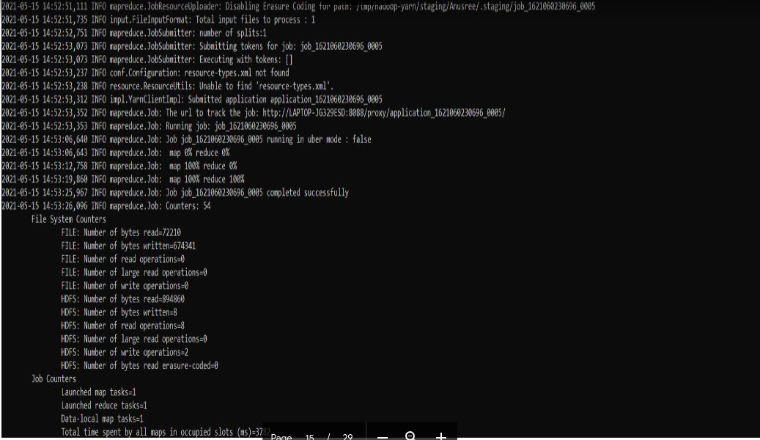

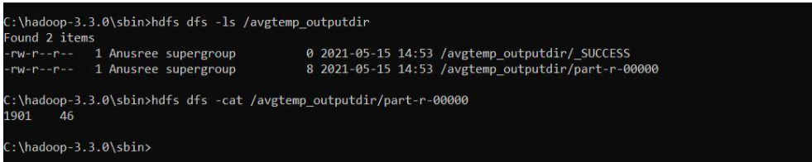

b) find the mean max temperature for every month

MeanMax
MeanMaxDriver.class
package meanmax;
import org.apache.hadoop.fs.Path;
import org.apache.hadoop.io.IntWritable;
import org.apache.hadoop.io.Text;
import org.apache.hadoop.mapreduce.Job;
import org.apache.hadoop.mapreduce.lib.input.FileInputFormat;
import org.apache.hadoop.mapreduce.lib.output.FileOutputFormat;
public class MeanMaxDriver {
public static void main(String[] args) throws Exception {
if (args.length != 2) {
System.err.println(&quot;Please Enter the input and output
parameters&quot;);
System.exit(-1);
}
Job job = new Job();
job.setJarByClass(MeanMaxDriver.class);
job.setJobName(&quot;Max temperature&quot;);
FileInputFormat.addInputPath(job, new Path(args[0]));
FileOutputFormat.setOutputPath(job, new Path(args[1]));
job.setMapperClass(MeanMaxMapper.class);
job.setReducerClass(MeanMaxReducer.class);
job.setOutputKeyClass(Text.class);
job.setOutputValueClass(IntWritable.class);
System.exit(job.waitForCompletion(true) ? 0 : 1);
}
}
MeanMaxMapper.class
package meanmax;

import java.io.IOException;
import org.apache.hadoop.io.IntWritable;
import org.apache.hadoop.io.LongWritable;
import org.apache.hadoop.io.Text;
import org.apache.hadoop.mapreduce.Mapper;
public class MeanMaxMapper extends Mapper&lt;LongWritable, Text,
Text, IntWritable&gt; {
public static final int MISSING = 9999;
public void map(LongWritable key, Text value,
Mapper&lt;LongWritable, Text, Text, IntWritable&gt;.Context context)
throws IOException, InterruptedException {
int temperature;
String line = value.toString();
String month = line.substring(19, 21);
if (line.charAt(87) == &#39;+&#39;) {
temperature = Integer.parseInt(line.substring(88, 92));
} else {
temperature = Integer.parseInt(line.substring(87, 92));
}
String quality = line.substring(92, 93);
if (temperature != 9999 &amp;&amp; quality.matches(&quot;[01459]&quot;))
context.write(new Text(month), new
IntWritable(temperature));
}
}
MeanMaxReducer.class
package meanmax;
import java.io.IOException;
import org.apache.hadoop.io.IntWritable;
import org.apache.hadoop.io.Text;
import org.apache.hadoop.mapreduce.Reducer;
public class MeanMaxReducer extends Reducer&lt;Text, IntWritable,
Text, IntWritable&gt; {
public void reduce(Text key, Iterable&lt;IntWritable&gt; values,
Reducer&lt;Text, IntWritable, Text, IntWritable&gt;.Context context)
throws IOException, InterruptedException {
int max_temp = 0;
int total_temp = 0;

int count = 0;
int days = 0;
for (IntWritable value : values) {
int temp = value.get();
if (temp &gt; max_temp)
max_temp = temp;
count++;
if (count == 3) {
total_temp += max_temp;
max_temp = 0;
count = 0;
days++;
}
}
context.write(key, new IntWritable(total_temp / days));
}
}

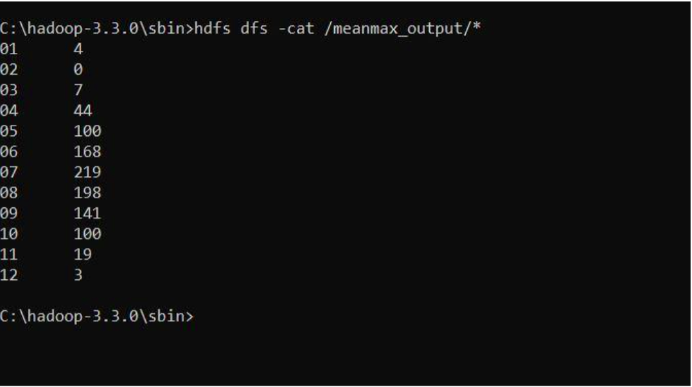

7. For a given Text file, Create a Map Reduce program to sort the content in an alphabetic order
listing only top 10 maximum occurrences of words.
package samples.topn;
import java.io.IOException;
import java.util.StringTokenizer;
import org.apache.hadoop.conf.Configuration;
import org.apache.hadoop.fs.Path;
import org.apache.hadoop.io.IntWritable;
import org.apache.hadoop.io.Text;
import org.apache.hadoop.mapreduce.Job;
import org.apache.hadoop.mapreduce.Mapper;
import org.apache.hadoop.mapreduce.lib.input.FileInputFormat;
import org.apache.hadoop.mapreduce.lib.output.FileOutputFormat;
import org.apache.hadoop.util.GenericOptionsParser;
public class TopN {
public static void main(String[] args) throws Exception {
Configuration conf = new Configuration();
String[] otherArgs = (new GenericOptionsParser(conf,
args)).getRemainingArgs();
if (otherArgs.length != 2) {
System.err.println(&quot;Usage: TopN &lt;in&gt; &lt;out&gt;&quot;);
System.exit(2);
}
Job job = Job.getInstance(conf);
job.setJobName(&quot;Top N&quot;);
job.setJarByClass(TopN.class);
job.setMapperClass(TopNMapper.class);
job.setReducerClass(TopNReducer.class);
job.setOutputKeyClass(Text.class);
job.setOutputValueClass(IntWritable.class);
FileInputFormat.addInputPath(job, new Path(otherArgs[0]));
FileOutputFormat.setOutputPath(job, new
Path(otherArgs[1]));
System.exit(job.waitForCompletion(true) ? 0 : 1);
}
public static class TopNMapper extends Mapper&lt;Object, Text,
Text, IntWritable&gt; {
private static final IntWritable one = new IntWritable(1);

private Text word = new Text();
private String tokens = &quot;[_|$#&lt;&gt;\\^=\\[\\]\\*/\\\\,;,.\\-
:()?!\&quot;&#39;]&quot;;
public void map(Object key, Text value, Mapper&lt;Object,
Text, Text, IntWritable&gt;.Context context) throws IOException,
InterruptedException {
String cleanLine =
value.toString().toLowerCase().replaceAll(this.tokens, &quot; &quot;);
StringTokenizer itr = new StringTokenizer(cleanLine);
while (itr.hasMoreTokens()) {
this.word.set(itr.nextToken().trim());
context.write(this.word, one);
}
}
}
}

TopNCombiner.class
package samples.topn;
import java.io.IOException;
import org.apache.hadoop.io.IntWritable;
import org.apache.hadoop.io.Text;
import org.apache.hadoop.mapreduce.Reducer;
public class TopNCombiner extends Reducer&lt;Text, IntWritable,
Text, IntWritable&gt; {
public void reduce(Text key, Iterable&lt;IntWritable&gt; values,
Reducer&lt;Text, IntWritable, Text, IntWritable&gt;.Context context)
throws IOException, InterruptedException {
int sum = 0;
for (IntWritable val : values)
sum += val.get();
context.write(key, new IntWritable(sum));
}
}
TopNMapper.class

package samples.topn;
import java.io.IOException;
import java.util.StringTokenizer;
import org.apache.hadoop.io.IntWritable;
import org.apache.hadoop.io.Text;
import org.apache.hadoop.mapreduce.Mapper;
public class TopNMapper extends Mapper&lt;Object, Text, Text,
IntWritable&gt; {
private static final IntWritable one = new IntWritable(1);
private Text word = new Text();
private String tokens = &quot;[_|$#&lt;&gt;\\^=\\[\\]\\*/\\\\,;,.\\-
:()?!\&quot;&#39;]&quot;;
public vo```\\id map(Object key, Text value, Mapper&lt;Object,
Text, Text, IntWritable&gt;.Context context) throws IOException,
InterruptedException {
String cleanLine =
value.toString().toLowerCase().replaceAll(this.tokens, &quot; &quot;);
StringTokenizer itr = new StringTokenizer(cleanLine);
while (itr.hasMoreTokens()) {
this.word.set(itr.nextToken().trim());
context.write(this.word, one);
}
}
}

TopNReducer.class
package samples.topn;
import java.io.IOException;
import java.util.HashMap;
import java.util.Map;
import org.apache.hadoop.io.IntWritable;
import org.apache.hadoop.io.Text;
import org.apache.hadoop.mapreduce.Reducer;
import utils.MiscUtils;

public class TopNReducer extends Reducer&lt;Text, IntWritable,
Text, IntWritable&gt; {
private Map&lt;Text, IntWritable&gt; countMap = new HashMap&lt;&gt;();
public void reduce(Text key, Iterable&lt;IntWritable&gt; values,
Reducer&lt;Text, IntWritable, Text, IntWritable&gt;.Context context)
throws IOException, InterruptedException {
int sum = 0;
for (IntWritable val : values)
sum += val.get();
this.countMap.put(new Text(key), new IntWritable(sum));
}
protected void cleanup(Reducer&lt;Text, IntWritable, Text,
IntWritable&gt;.Context context) throws IOException,
InterruptedException {
Map&lt;Text, IntWritable&gt; sortedMap =
MiscUtils.sortByValues(this.countMap);
int counter = 0;
for (Text key : sortedMap.keySet()) {
if (counter++ == 20)
break;
context.write(key,sortedMap.get(key));
}
}

output:

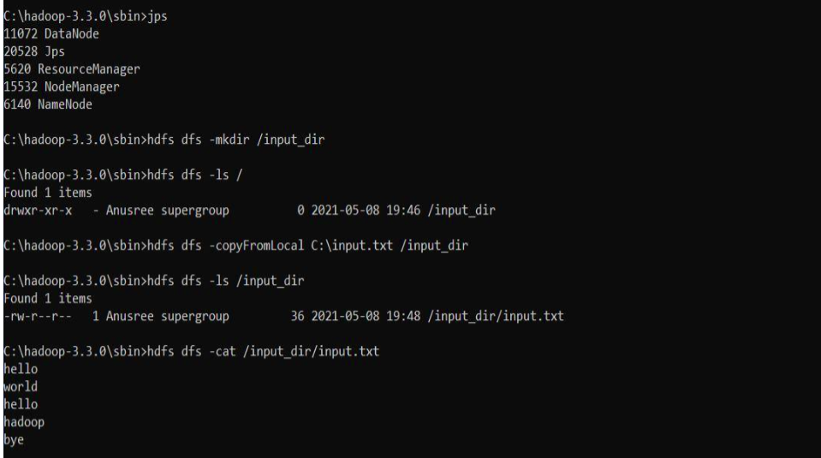

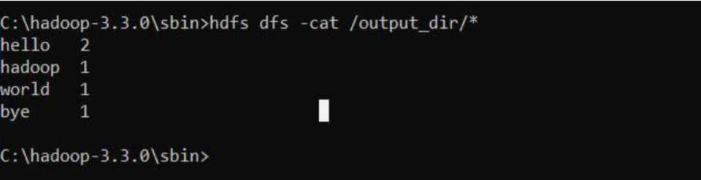

8. Create a Map Reduce program to demonstrating join operation

// JoinDriver.java
import org.apache.hadoop.conf.Configured;
import org.apache.hadoop.fs.Path;
import org.apache.hadoop.io.Text;
import org.apache.hadoop.mapred.*;
import org.apache.hadoop.mapred.lib.MultipleInputs;
import org.apache.hadoop.util.*;
public class JoinDriver extends Configured implements Tool {
public static class KeyPartitioner implements Partitioner&lt;TextPair,
Text&gt; {
@Override
public void configure(JobConf job) {}
@Override
public int getPartition(TextPair key, Text value, int numPartitions) {
return (key.getFirst().hashCode() &amp; Integer.MAX_VALUE) %
numPartitions;
}
}
@Override
public int run(String[] args) throws Exception {
if (args.length != 3) {
System.out.println(&quot;Usage: &lt;Department Emp Strength input&gt;
&lt;Department Name input&gt; &lt;output&gt;&quot;);
return -1;
}
JobConf conf = new JobConf(getConf(), getClass());

conf.setJobName(&quot;Join &#39;Department Emp Strength input&#39; with
&#39;Department Name
input&#39;&quot;);
Path AInputPath = new Path(args[0]);
Path BInputPath = new Path(args[1]);
Path outputPath = new Path(args[2]);
MultipleInputs.addInputPath(conf, AInputPath, TextInputFormat.class,
Posts.class);
MultipleInputs.addInputPath(conf, BInputPath, TextInputFormat.class,
User.class);
FileOutputFormat.setOutputPath(conf, outputPath);
conf.setPartitionerClass(KeyPartitioner.class);
conf.setOutputValueGroupingComparator(TextPair.FirstComparator.cl
ass);
conf.setMapOutputKeyClass(TextPair.class);
conf.setReducerClass(JoinReducer.class);
conf.setOutputKeyClass(Text.class);
JobClient.runJob(conf);
return 0;
}
public static void main(String[] args) throws Exception {

int exitCode = ToolRunner.run(new JoinDriver(), args);
System.exit(exitCode);
}
}
// JoinReducer.java
import java.io.IOException;
import java.util.Iterator;
import org.apache.hadoop.io.Text;
import org.apache.hadoop.mapred.*;
public class JoinReducer extends MapReduceBase implements
Reducer&lt;TextPair, Text, Text,
Text&gt; {
@Override
public void reduce (TextPair key, Iterator&lt;Text&gt; values,
OutputCollector&lt;Text, Text&gt;
output, Reporter reporter)
throws IOException
{
Text nodeId = new Text(values.next());
while (values.hasNext()) {
Text node = values.next();
Text outValue = new Text(nodeId.toString() + &quot;\t\t&quot; + node.toString());
output.collect(key.getFirst(), outValue);
}
}
}
// User.java
import java.io.IOException;

import java.util.Iterator;
import org.apache.hadoop.conf.Configuration;
import org.apache.hadoop.fs.FSDataInputStream;
import org.apache.hadoop.fs.FSDataOutputStream;
import org.apache.hadoop.fs.FileSystem;
import org.apache.hadoop.fs.Path;
import org.apache.hadoop.io.LongWritable;
import org.apache.hadoop.io.Text;
import org.apache.hadoop.mapred.*;
import org.apache.hadoop.io.IntWritable;
public class User extends MapReduceBase implements
Mapper&lt;LongWritable, Text, TextPair,
Text&gt; {
@Override
public void map(LongWritable key, Text value,
OutputCollector&lt;TextPair, Text&gt; output,
Reporter reporter)
throws IOException
{
String valueString = value.toString();
String[] SingleNodeData = valueString.split(&quot;\t&quot;);
output.collect(new TextPair(SingleNodeData[0], &quot;1&quot;), new
Text(SingleNodeData[1]));
}
}
//Posts.java
import java.io.IOException;

import org.apache.hadoop.io.*;
import org.apache.hadoop.mapred.*;
public class Posts extends MapReduceBase implements
Mapper&lt;LongWritable, Text, TextPair,
Text&gt; {
@Override
public void map(LongWritable key, Text value,
OutputCollector&lt;TextPair, Text&gt; output,
Reporter reporter)
throws IOException
{
String valueString = value.toString();
String[] SingleNodeData = valueString.split(&quot;\t&quot;);
output.collect(new TextPair(SingleNodeData[3], &quot;0&quot;), new
Text(SingleNodeData[9]));
}
}
// TextPair.java
import java.io.*;
import org.apache.hadoop.io.*;
public class TextPair implements WritableComparable&lt;TextPair&gt; {
private Text first;
private Text second;
public TextPair() {
set(new Text(), new Text());
}

public TextPair(String first, String second) {
set(new Text(first), new Text(second));
}
public TextPair(Text first, Text second) {
set(first, second);
}
public void set(Text first, Text second) {
this.first = first;
this.second = second;
}
public Text getFirst() {
return first;
}
public Text getSecond() {
return second;
}
@Override
public void write(DataOutput out) throws IOException {
first.write(out);
second.write(out);
}
@Override
public void readFields(DataInput in) throws IOException {
first.readFields(in);
second.readFields(in);
}
@Override
public int hashCode() {
return first.hashCode() * 163 + second.hashCode();

}
@Override
public boolean equals(Object o) {
if (o instanceof TextPair) {
TextPair tp = (TextPair) o;
return first.equals(tp.first) &amp;&amp; second.equals(tp.second);
}
return false;
}
@Override
public String toString() {
return first + &quot;\t&quot; + second;
}
@Override
public int compareTo(TextPair tp) {
int cmp = first.compareTo(tp.first);
if (cmp != 0) {
return cmp;
}
return second.compareTo(tp.second);
}
// ^^ TextPair
// vv TextPairComparator
public static class Comparator extends WritableComparator {
private static final Text.Comparator TEXT_COMPARATOR = new
Text.Comparator();
public Comparator() {
super(TextPair.class);
}

@Override
public int compare(byte[] b1, int s1, int l1,
byte[] b2, int s2, int l2) {
try {
int firstL1 = WritableUtils.decodeVIntSize(b1[s1]) + readVInt(b1, s1);
int firstL2 = WritableUtils.decodeVIntSize(b2[s2]) + readVInt(b2, s2);
int cmp = TEXT_COMPARATOR.compare(b1, s1, firstL1, b2, s2,
firstL2);
if (cmp != 0) {
return cmp;
}
return TEXT_COMPARATOR.compare(b1, s1 + firstL1, l1 - firstL1,
b2, s2 + firstL2, l2 - firstL2);
} catch (IOException e) {
throw new IllegalArgumentException(e);
}
}
}
static {
WritableComparator.define(TextPair.class, new Comparator());
}
public static class FirstComparator extends WritableComparator {
private static final Text.Comparator TEXT_COMPARATOR = new
Text.Comparator();
public FirstComparator() {
super(TextPair.class);
}
@Override
public int compare(byte[] b1, int s1, int l1,
byte[] b2, int s2, int l2) {

try {
int firstL1 = WritableUtils.decodeVIntSize(b1[s1]) + readVInt(b1, s1);
int firstL2 = WritableUtils.decodeVIntSize(b2[s2]) + readVInt(b2, s2);
return TEXT_COMPARATOR.compare(b1, s1, firstL1, b2, s2, firstL2);
} catch (IOException e) {
throw new IllegalArgumentException(e);
}
}
@Override
public int compare(WritableComparable a, WritableComparable b) {
if (a instanceof TextPair &amp;&amp; b instanceof TextPair) {
return ((TextPair) a).first.compareTo(((TextPair) b).first);
}
return super.compare(a, b);
}
} }

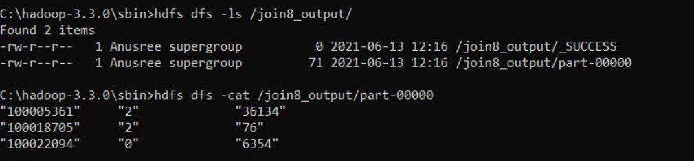

9. Program to print word count on scala shell and print “Hello world” on scala IDE

$scala

scala> println("Hello World!");
Hello World!

